**­**



Lab Manual

UNIVERSITY OF LAYYAH

|  |  |
| --- | --- |
| Course Title: | Data Structures |
| Course Code: | CS_301 |
| Submitted by: | Alina Liaquat |
| Submitted to: | Sir Arshad |
| Roll No: | UL_BSCSM_23_21 |

**­­**

1D Arrays:

1: Write a C++ program which prompts the user to enter 4 elements in an array. The program should sort the array elements in ascending order and then display the sorted array to the user

|  |
| --- |
| #include<iostream>  using namespace std;  int main()  {  int temporary;  int array[3];  cout<<"Program to convert the array entered by the user in ascending order: "<<endl;  for(int i=0; i<=3; i++)  {  cout<<"Enter a Number: ";  cin>>array[i];  }    if(array[0]>array[1])  {  temporary=array[0];  array[0]=array[1];  array[1]=temporary;  }    if(array[0]>array[2])  {  temporary=array[0];  array[0]=array[2];  array[2]=temporary;  }    if(array[0]>array[3])  {  temporary=array[0];  array[0]=array[3];  array[3]=temporary;  }    if(array[1]>array[2])  {  temporary=array[1];  array[1]=array[2];  array[2]=temporary;  }    if(array[1]>array[3])  {  temporary=array[1];  array[1]=array[3];  array[3]=temporary;  }    if(array[2]>array[3])  {  temporary=array[2];  array[2]=array[3];  array[3]=temporary;  }      cout<<"Ascending order of given array is: "<<endl;  for(int j=0; j<=3; j++)  {  cout<<array[j]<<endl;  }      return 0;  } |

Output:

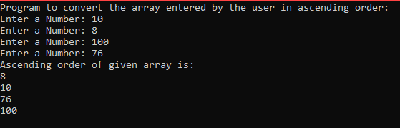

2: C++ program which prompts the user to enter the size of array. Then user is asked to input the elements of array. The program should find any negative element in the array. If there is any negative element in array, then user is asked to enter positive number instead. Now, the negative numbers of array should be replaced with positive number entered by the user. Finally, the array with all positive numbers should be displayed to the user.

|  |
| --- |
| #include<iostream>  using namespace std;  int main()  {  int c;  int size;  int array[size];  cout<<"Please enter the size of array: ";  cin>>size;  for(c=0; c<size; c++)  {  cout<<"\nPlease enter the element of array: ";  cin>>array[c];  }  cout<<endl<<endl;  cout<<endl<<"The elements of array are: ";  for(int y=0; y<size; y++)  {  cout<<array[y]<<" ";  }  cout<<endl<<endl;  for(int e=0; e<size; e++)  {  if(array[e]<0)  {  cout<<"Negative number found at position " << e <<" please enter any positive number: ";  cin>>array[e];  }  }  cout<<"The array with all posiive numbers is: ";  for(int d=0; d<size; d++)  {    cout<<array[d]<<" ";  }  return 0;  } |

Output:

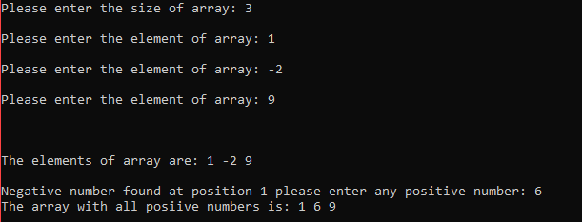

3: C++ program which prompts the user to enter array size. Then he is prompted to enter the array elements. Then array elements are displayed to the user. Then user is asked to enter any number from the array to check the number of occurrences of that specific element in the array and display the number of occurrence of that element to the user.

|  |
| --- |
| #include<iostream>  using namespace std;  int main()  {  int user_input;  int size;  int count;  int i;  cout<<"Enter the size of array: ";  cin>>size;  int array[size];    for(i=0; i<size; i++)  {  cout<<"Enter array element:";  cin>>array[i];  }    cout<<endl<<endl<<"Array elements are: ";  for(i=0; i<size; i++)  {  cout<<array[i]<<" ";  }    cout<<endl<<endl<<"From the array elements enter any number whoose occurrences you want to count: ";  cin>>user_input;    for(i=0; i<size; i++)  {  if(array[i]==user_input)  {  count++;  }  }    cout<<endl<<endl<<"The number of occurrances of "<<user_input<<" in array is: "<<count;      return 0;  } |

Output:

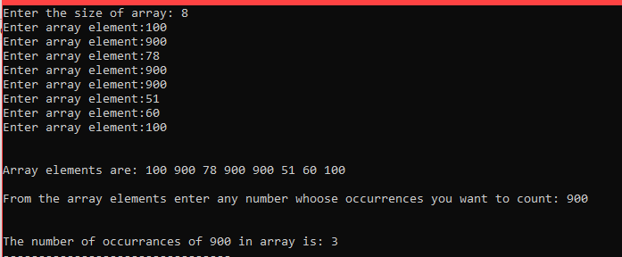

4: A C++ program which prompts the user to enter array size and input the array elements. The array should be displayed to the user. After that user is asked to enter the choice whether he wants to see the odd or only even numbers from the array. The even or odd numbers from the array should be displayed on the basis of user’s choice

|  |
| --- |
| #include<iostream>  using namespace std;  int main()  {  int user_input;  int size;  char choice;  int counter;  cout<<"Please enter the size of array: ";  cin>>size;  int array[size];      for(counter=0; counter<size; counter++)  {  cout<<"Enter the element you want to store in array:";  cin>>array[counter];  }      cout<<"\n---The elements are---: ";      for(counter=0; counter<size; counter++)  {  cout<<array[counter]<<" ";  }    cout<<endl;  cout<<endl;  cout<<"Enter the choice:"<<endl;  cout<<"Choice o for odd numbers & choice e for even numbers: ";  cin>>choice;    if(choice=='e')  {  cout<<"Even numbers in array are:";  for(counter=0; counter<size; counter++)  {  if(array[counter]%2==0)  {  cout<<array[counter]<<" ";  }  }  }      else  {  cout<<"Odd numbers in array are:";  for(counter=0; counter<size; counter++)  {  if(array[counter]%2!=0)  {  cout<<array[counter]<<" ";  }  }  }    return 0;  } |

Output:

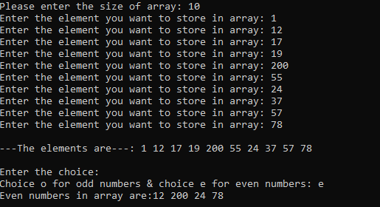

5. A C++ program which prompts the user to enter array size and input the array elements. The array should be displayed to the user.

Then program should display the count of positive and negative elements of array.

|  |
| --- |
| #include<iostream>  using namespace std;  int main()  {  //program-- Count the positive and -ve numbers in an array  int var;  int count1=0;  int count2=0;  int size;  int array[size];  cout<<"Please enter the size of array: ";  cin>>size;  for(var=0; var<size; var++)  {  cout<<"\nPlease enter the element of array: ";  cin>>array[var];  }  cout<<endl<<endl;  cout<<endl<<"The elements of array are: ";  for(var=0; var<size; var++)  {  cout<<array[var]<<" ";  }  cout<<endl<<endl;      for(var=0; var<size; var++)  {  if(array[var]<0)  {  count1++;  }  }  cout<<endl<<"Total number of negative elements in array are: "<<count1;      for(var=0; var<size; var++)  {  if(array[var]>0)  {  count2++;  }  }    cout<<endl<<"Total number of positive elements in array are: "<<count2;      return 0;  } |

Output:

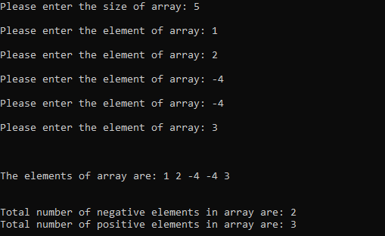

2D Arrays:

6: A C++ program to prompt the user to enter the row and column size to make a 2D Array. Then user is prompted to input the 2D array elements. The program should then display the 2D array to the user.

|  |
| --- |
| #include<iostream>  using namespace std;  int main()  {  int row,column;  cout<<"Enter the row size: ";  cin>>row;  cout<<"Enter the column size: ";  cin>>column;  int array[row][column];  int i,j;  cout<<"\n2D Array \n";    for(i=0;i<row;i++)  {  for(j=0;j<column;j++)  {  cout<<"\nInput the 2D array \n";  cout<<"array["<<i<<"]["<<j<<"]"<<endl;  cin>>array[i][j];  }  }  cout<<endl<<endl<<"2D Array elements are: "<<endl;    for(i=0;i<row;i++)  {  for(j=0;j<column;j++)  {  cout<<array[i][j]<<"\t";    }  cout<<endl;  }  return 0;  } |

Output:

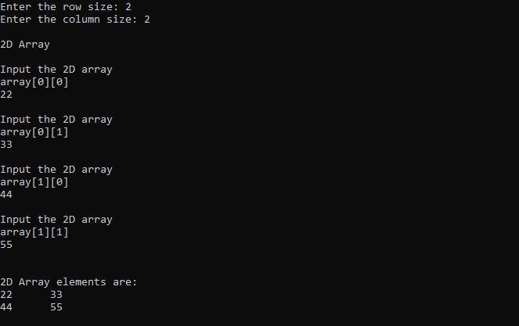

7: Write a C++ program and declare a structure named student using struct keyword. In the structure define the student id, age and name. Using the student object take the user_input for id, age and name. The program should then display the student name, age and id.

|  |
| --- |
| #include<iostream>  #include<string.h>  using namespace std;  int main()  {    struct students  {  int id,age;  string name;    };  students s;  cout<<"Enter student ID : ";  cin>>s.id;  cin.ignore();  cout<<"Enter student age : ";  cin>>s.age;  cin.ignore();  cout<<"Enter student name: ";  getline(cin,s.name);  cout<<endl;  cout<<"Student ID is: "<<s.id<<endl;  cout<<"Student Age is: "<<s.age<<endl;  cout<<"Student name is: "<<s.name<<endl;  return 0;    } |

Output:

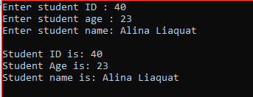

8: C++ program which prompts the user to enter the size and elements of 2 2D arrays. The program should calculate the sum of both 2D Arrays then it should display the sum of both 2D Arrays.

|  |
| --- |
| #include<iostream>  using namespace std;  int main()  {  int i,j;  int row,col;  cout<<"Enter the row size for array: ";  cin>>row;  cout<<"Enter the column size for array: ";  cin>>col;    int array1[row][col];  int array2[row][col];    //1st 2D Array    for(i=0;i<row;i++)  {  for(j=0;j<col;j++)  {  cout<<"array["<<i<<"]["<<j<<"]"<<endl;  cin>>array1[i][j];  }  }      cout<<endl<<endl;  cout<<"The 1st 2D array is: ";  cout<<endl;  for(i=0;i<row;i++)  {  for(j=0;j<col;j++)  {  cout<<array1[i][j]<<"\t";  }  cout<<endl;  }  cout<<endl<<endl;    // 2nd 2D array    for(i=0;i<row;i++)  {  for(j=0;j<col;j++)  {  cout<<"array["<<i<<"]["<<j<<"]"<<endl;  cin>>array2[i][j];  }  }      cout<<endl<<endl;  cout<<"The 2nd 2D array is: ";  cout<<endl;  for(i=0;i<row;i++)  {  for(j=0;j<col;j++)  {  cout<<array2[i][j]<<"\t";  }  cout<<endl<<endl;  }    cout<<endl<<"The addition of both 2d arrays is "<<endl;  for(i=0;i<row;i++)  {  for(j=0;j<col;j++)  {  cout<<array1[i][j]+array2[i][j]<<"\t";  }  cout<<endl;  }    return 0;  } |

Output:

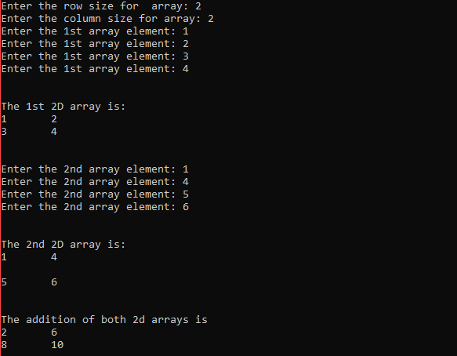

9: C++ program which prompts the user to enter a 2D Array. The program should display the 2D array 1st and then it should display the rows of the 2D Array in the reverse order.

|  |
| --- |
| #include<iostream>  using namespace std;  int main()  {  int row,col,i,j;  cout<<"Enter the row size of 2D Array: ";  cin>>row;  cout<<"Enter the column size for the 2D Array: ";  cin>>col;  int array[row][col];  for(i=0;i<row;i++)  {  for(j=0;j<col;j++)  {  cout<<"Enter the 2D array element: ";  cin>>array[i][j];  }  }    cout<<"The 2D Array elements are:"<<endl<<endl;  for(i=0;i<row;i++)  {  for(j=0;j<col;j++)  {  cout<<array[i][j]<<"\t";  }  cout<<endl;  }      cout<<endl<<endl<<"The 2D Array in rows reverse order is: ";  cout<<endl;    for(i=row-1;i>=0;i--)  {  for(j=0;j<col;j++)  {  cout<<array[i][j]<<"\t";  }  cout<<endl;  }    return 0;  } |

Output:

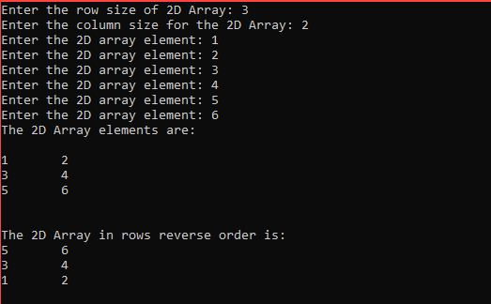

3: Linear Search Program